Noosa lions Football club

  - partnership opportunities

the club
  - partnership opportunities
  - 2023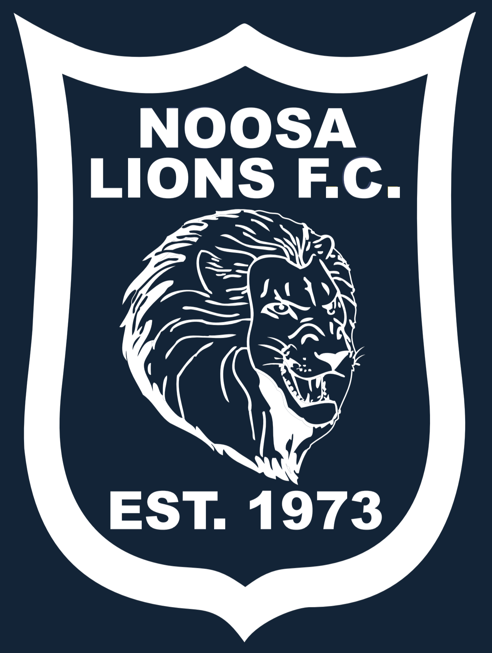
700 members
550 junior members from 5-18 years
150 senior member
2 x Womens Teams
6 x Mens Teams
65 x Junior teams
FFA Level 1 accreditation
Good Food Good Sports Level 3 accreditation
Established in 1973, Noosa Lions Football Club has grown to be the largest football club on the Sunshine Coast. In 2021 there were 693 registered players, competing in 74 teams, with both male and female members aged from 5 to 80+ years old.
2022 was another highly successful year for Noosa Lions. Our FQPL3 men finished 3rd while our FQPL3 u23s finished the regular season in 2nd and won the Grand Final. Our 1st Division Women had an undefeated season winning the Premiership and Grand Final. We also had another 8 junior and senior teams compete in the final’s with our u13 girls winning the premiership and u14 div 1 boys the Grand Final.
On a weekly basis the club welcome teams from all over the Sunshine Coast from as far afield as Bribie Island to Maleny to Gympie.
In 2023 we envisage our club to grow to 720 members. Your brand exposure and ability to reach thousands of Sunshine Coast residents each week is without a doubt one of the best investments you could make for your business. Packages can be adjusted dependent on needs and tailored to budget.

  - platinum senior Sponsorship
  - investment $6000 for FQPL3 men or women or both for $9000

- Front position on Noosa Lions Football Club Premier (FQPL3) Men’s and u23 Men’s shirts or FQPL3 Womens and u23s (great opportunity with the women’s world cup this year)
- Business logo on back of Junior Training shirts approx. 550
- One 2000x950 sign in full colour including front fence along field 2
- Sponsorship recognition at all home games at half time – ground announcements.
- Invitation to Sponsors night at Noosa Lions Football Club including catering and drinks for 6 adults.
- Free entry to Final series hosted by Noosa Lions Football Club for 4 adults.
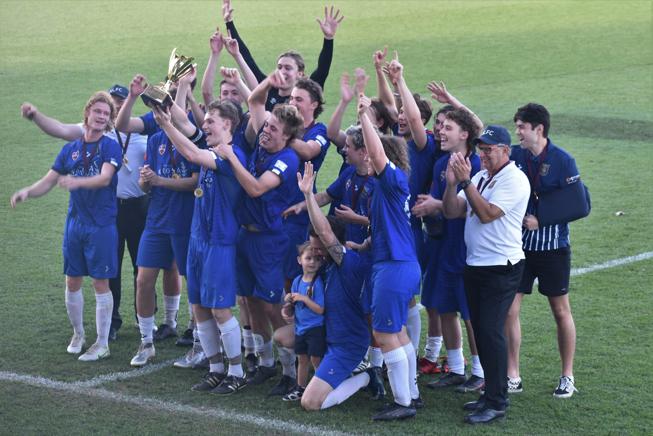

  - platinum junior Sponsorship
  - investment $6000
- Front position on Noosa Lions Football Club Junior Training shirt – 500 junior members
- Business logo on sleeve of Noosa Lions Football Club Premier (FQPL3) Men’s and Women’s shirts
- One 2000x950 sign in full colour including front fence along field 2
- Sponsorship recognition at all home games at half time – ground announcements.
- Invitation to Sponsors night at Noosa Lions Football Club including catering and drinks for 6 adults.
- Free entry to Final series hosted by Noosa Lions Football Club for 4 adults.

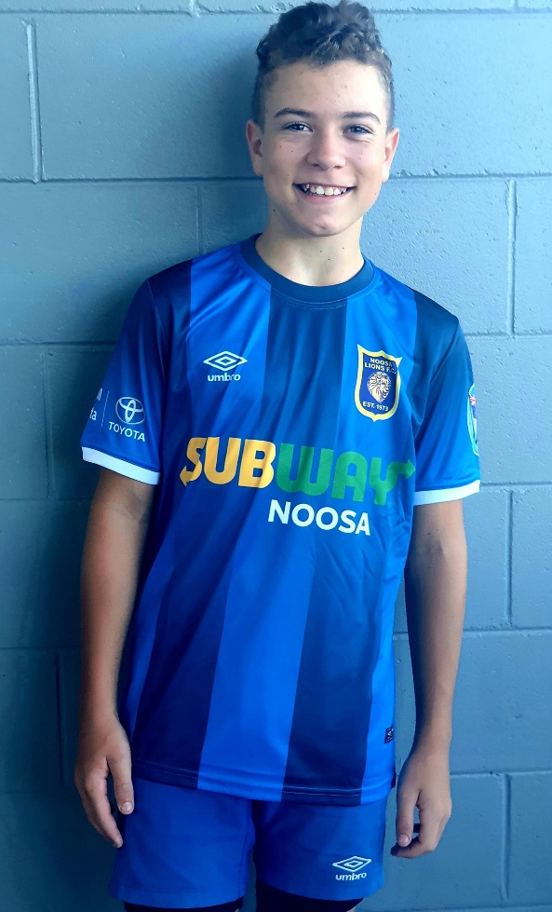

gold Sponsorship
investment $4500

- Business Logo on back of training shirts of junior members – approximately 550 shirts
- Business Logo on back of Premier (|FQPL3) Men’s and u23’s Men’s shirts
- One 2000x950 sign in full colour including front fence along field 2
- Sponsorship recognition at all home games at half time – ground announcements.
- Invitation to Sponsors night at Noosa Lions Football Club including catering and drinks for 6 adults.
- Free entry to Final series hosted by Noosa Lions Football Club for 4 adults.

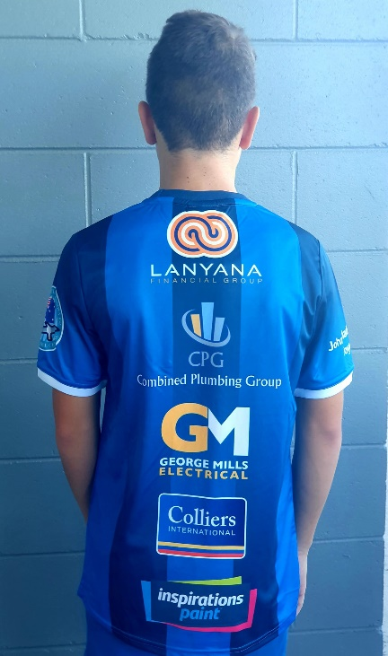

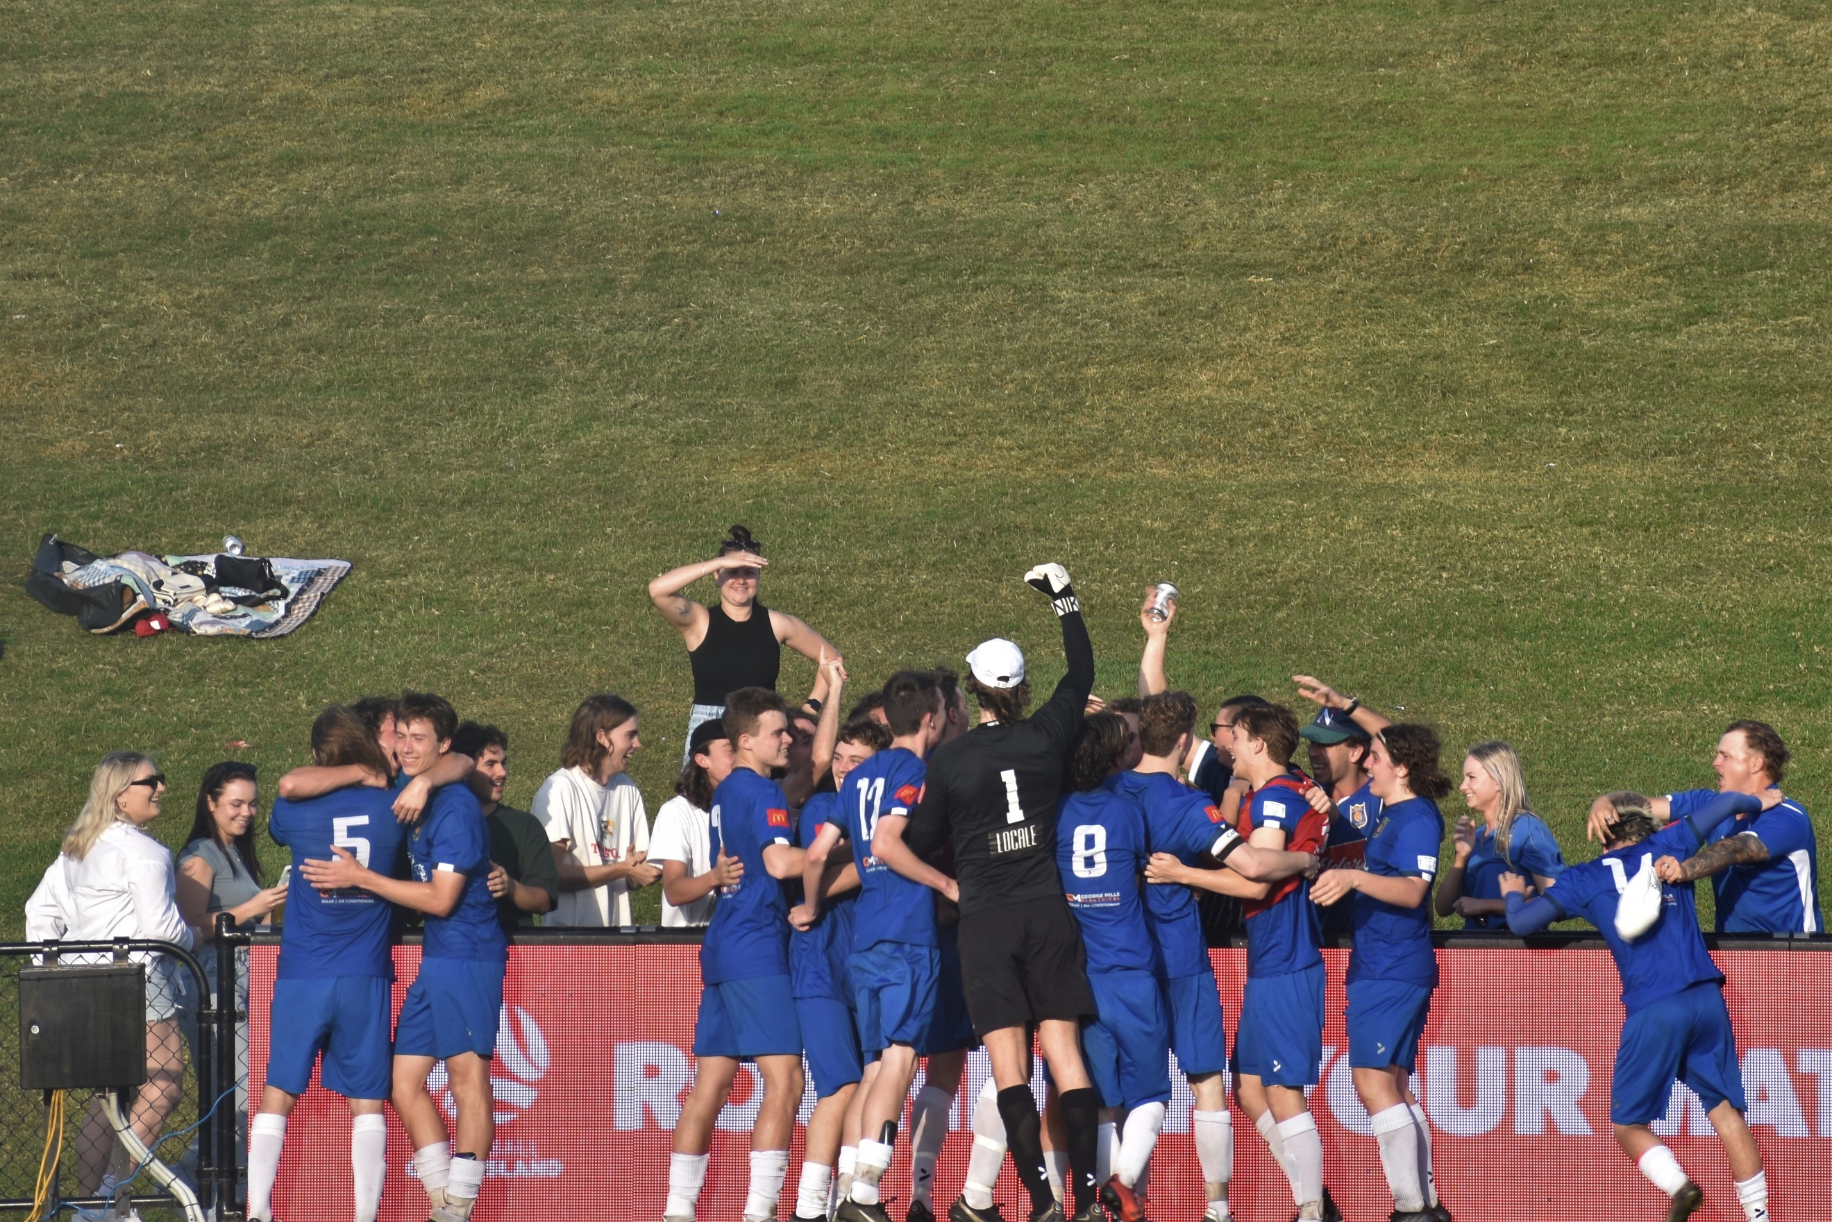

silver Sponsorship
investment $2500
- Business Logo on back of training shirts of junior members – approximately 550 shirts
- 1 X 2000mm x 900mm field sign in full colour
- Sponsorship recognition at all home games at half time – ground announcements.
- Invitation to Sponsors night at Noosa Lions Football Club including catering and drinks for 6 adults.

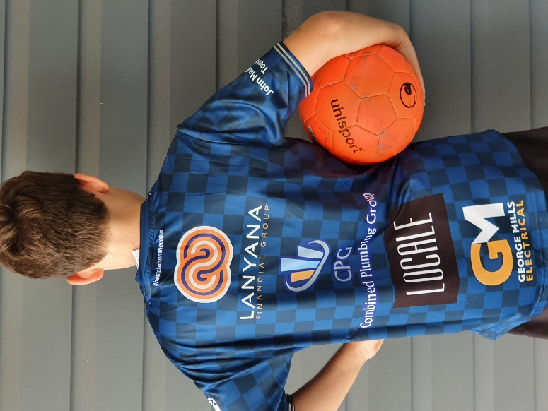
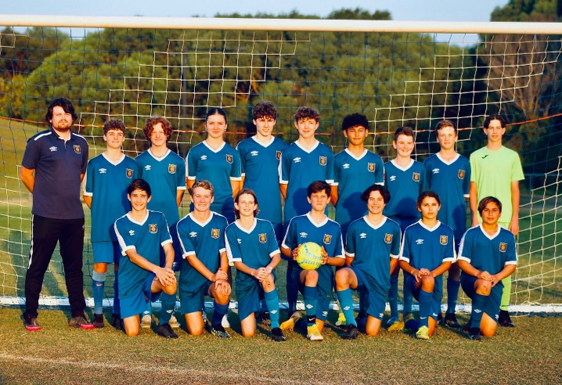

bronze senior Sponsorship
investment $2000
- Business Logo on front of FQPL3 Men and u23s or Women’s and u23s training shirts
- Business Logo on sleeve of Premier Men and u23s game shirts or Womens and u23 game shirts
- Prominent sign on Field 2 in front of club house – 2000mm x 900mm
- Sponsorship recognition at all home games at half time – ground announcements.
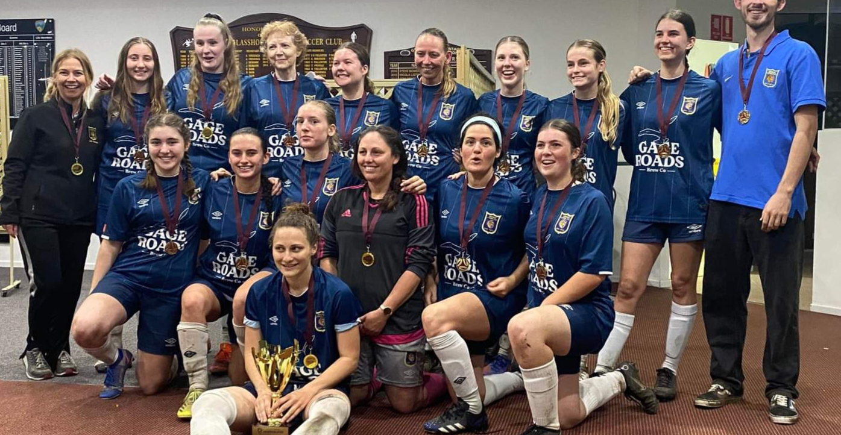
- Invitation to Sponsors night at Noosa Lions Football Club including catering and drinks for 6 adults.

  - bronze junior Sponsorship
  - investment $1,200

- Business Logo on front of 1 x Junior Team shirts (boys or girls teams)
- Business logo on sleeve of Junior Training shirts approx. 550
- Prominent sign on Field 2 in front of club house – 2000mm x 900mm
- Invitation to Sponsors night at Noosa Lions Football Club including catering and drinks for 2 adults.

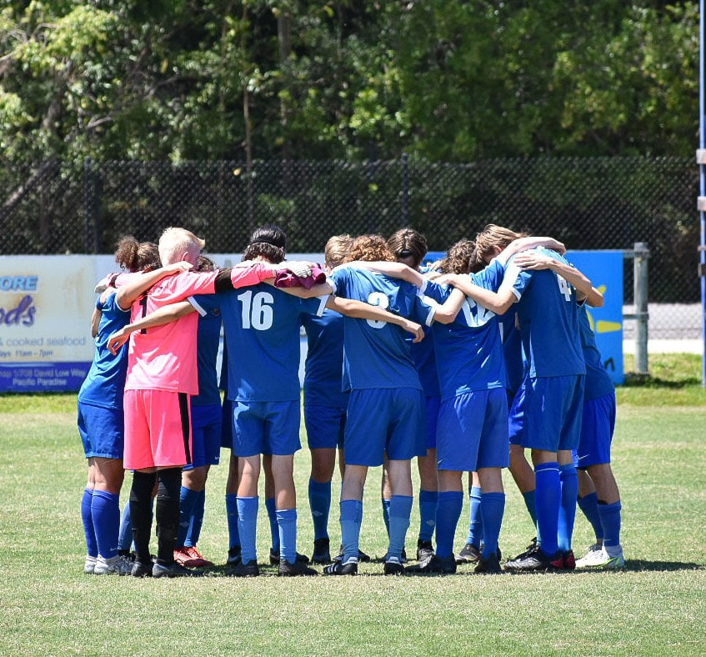

  - white Sponsorship
  - investment $600
- Business Logo on front of 1 x Mini Roos (under 6-12) Team jerseys

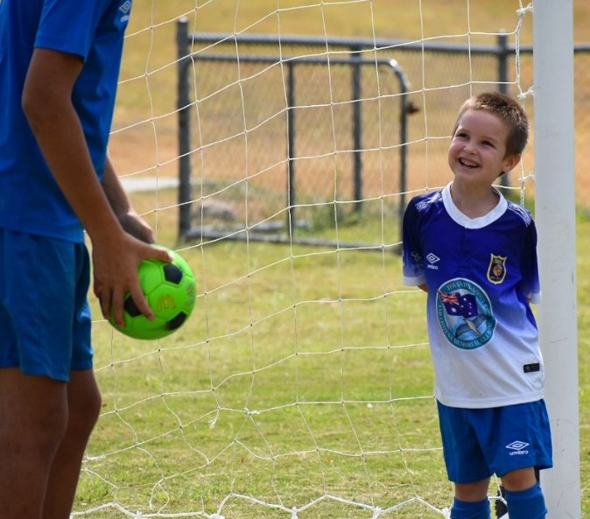

  - signage only Sponsorship
  - investment $650

- Prominent sign on Field 2 in front of club house – 2000mm x 900mm (including sign and artwork).
- Signage remains on field during 2023 season

For any questions please contact Secretary – Bec Whisker or email secretary@noosalionsfc.com

