 | 4.00pm | 4.45pm | 4.45pm | 5.30pm | 5.30pm
 | FIELD 4 | FIELD 3 | FIELD 4 | FIELD 1 | FIELD 2
18th Jan | Adidas All Stars  V  Goal Busters | Sunny’s Boys  V  Noosa Newbies | The Misfits  V  Red Devils | Noosalona FC  V  Real Noosa | Sunny’s Boys  v  Some Random Guys
25th Jan | Goal Busters  V  Noosalona FC | Some Random Guys  V  Adidas All Stars | Red Devils  V  Sunny’s Boys | Real Noosa  V  The Misfits | Adidas All Stars  V  Noosa Newbies
1st Feb | The Misfits  V  Goal Busters | Sunny’s Boys  V  Real Noosa | Noosalona FC  V  Adidas All Stars | Noosa Newbies  V  Red Devils | Noosalona FC  v  Some Random Guys
8th Feb | Sunny’s Boys  V  Adidas All Stars | Noosa Newbies  V  The Misfits | Red Devils  V  Noosalona FC | Some Random Guys  V  Real Noosa | Real Noosa  V  Goal Busters
15th Feb | Semi Finals  All teams play
22nd Feb | Grand Finals  All teams play
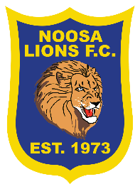
SUMMER 6S 2022
U11/12

Teams in Yellow at 5.15pm play 2 games that week

