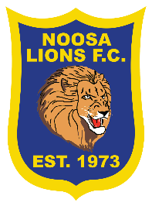
SUMMER 6S 2021
 | 6.50pm | 7.35pm | 8.20pm | 8.20pm
 | FIELD 1B | FIELD 1B | FIELD 1B | FIELD 2A
12th JAN | THE DENDONKAS  V  THE EMUS | DADSONS  V  EETSWA | DTM TEAM  V  BALLOTELLITUBIES FC | NOOSA UNITED  V  THE OLD LADIES
19TH JAN | DADSONS  V  THE OLD LADIES | DTM TEAM  V  THE OLD LADIES | THE EMUS  V  BALLOTELLITUBIES FC | THE DENDONKAS  V  EETSWA
26TH JAN | THE DENDONKAS  V  DTM TEAM | THE OLD LADIES  V  BALLOTELLITUBIES FC | DADSONS  V  NOOSA UNITED | EESTWA  V  THE EMUS
2ND FEB | EETSWA  V  DTM TEAM | THE DENDONKAS  V  THE OLD LADIES | NOOSA UNITED  V  BALLOTELLITUBIES FC | DADSONS  V  THE EMUS
9TH FEB | DADSONS  V  BALLOTELLITUBIES FC | EETSWA  V  THE OLD LADIES | NOOSA UNITED  V  THE DENDONKAS | DTM TEAM  V  THE EUMUS
16TH FEB |  | SEMI FINALS
23RD FEB |  | GRAND FINALS
MEN’S WHITE DRAW

