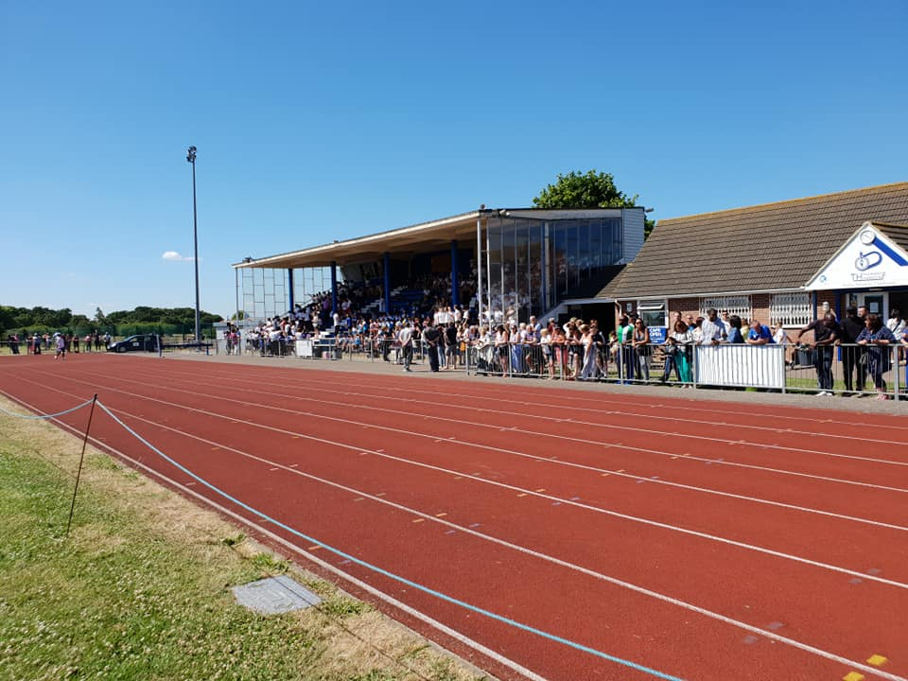
Thurrock Harriers Club Championships 2023

Saturday 2nd September
Closing date Thursday 24th August
All age groups from U11 to Masters
Events:
Track: 100m 200m 300m 400m 800m 1500m Short Hurdles 300H/400H
Field: LJ, TJ, HJ, SP, DT, HT, JT.
Applicants must be club members and can enter 3 events on the day.
£10 entry fee, regardless of the number of entries.
Results will be on Power of 10.
Entry forms can be downloaded from the Thurrock Harriers Facebook page, the Club website or ask at the clubhouse. Hand your completed form, including UKA number + entry fee to Karen Coshell, Gerry Heapy, or at the clubhouse.
Refreshments will be available in the clubhouse.
Members and parents are needed to help with judging and general running of the day. PLEASE volunteer.
Enquiries to:
gerry5heapy@hotmail.co.uk
Or
Karenlee123@hotmail.com

