Californian Nationals Tennessee 2020 Open winners circle

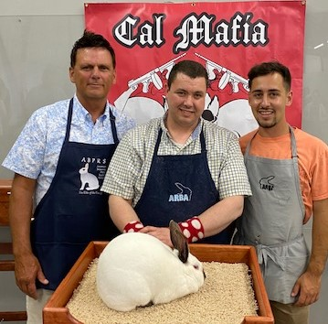
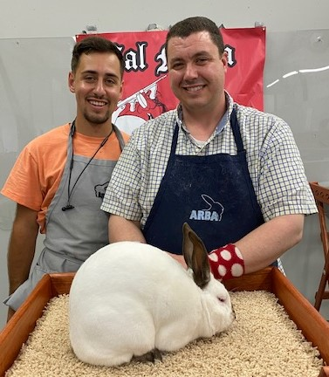
Best Sr Buck Best Sr Doe
Jonathan Herbert/Randy Shumaker Jonathan Herbert/Randy Shumaker
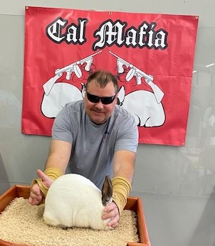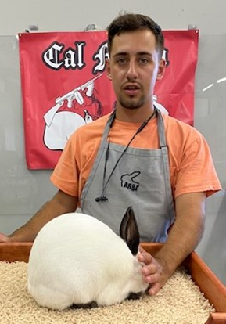
Best 6/8 Buck- BOS of Breed Best 6/8 Doe
Robert Donnell Jonathan Herbert/Randy Shumaker
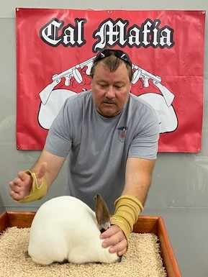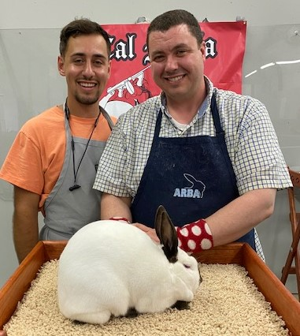
Best Jr Buck Best Jr Doe
Robert Donnell Jonathan Herbert/Randy Shumaker
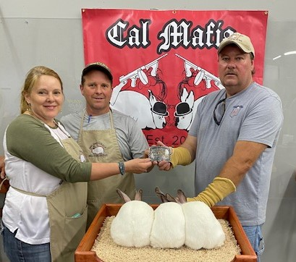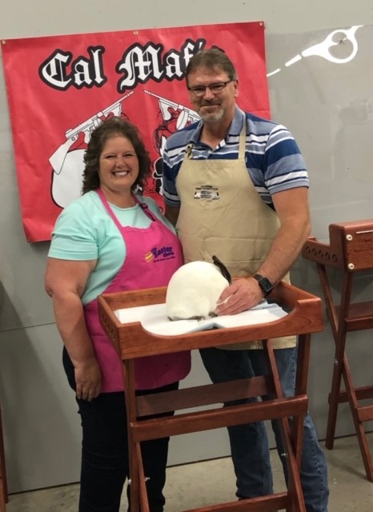
Best Meat Pen Best single Fryer
Travis/Jodi Britton Joan/Milton Simmons

