Californian Nationals Tennessee 2020 Youth winners circle

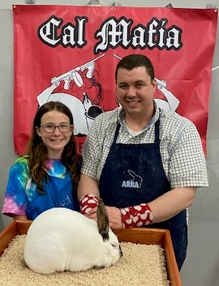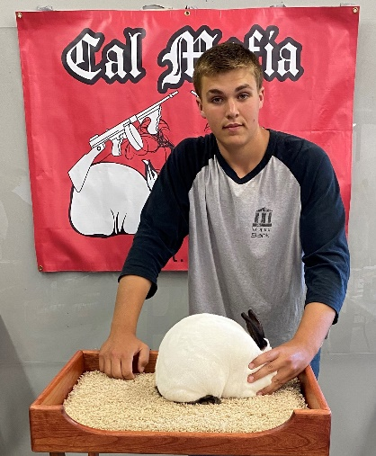
Best Sr Buck -BOS of Breed Best Sr Doe
Haydn Tinsley Josiah Searls

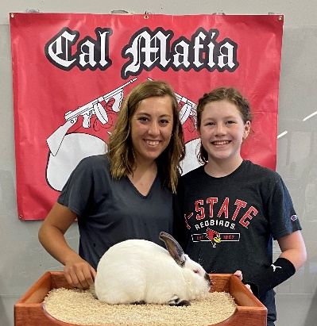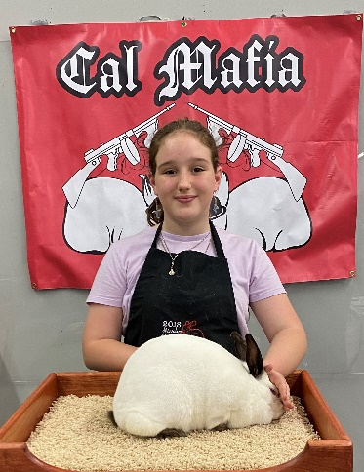
Best 6/8 Buck Best 6/8 Doe
Aiden/Kody/Kiley/Cheyenne Post Kaela Britton

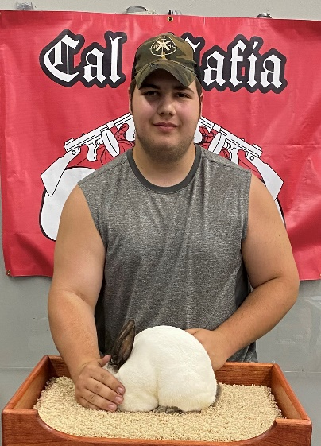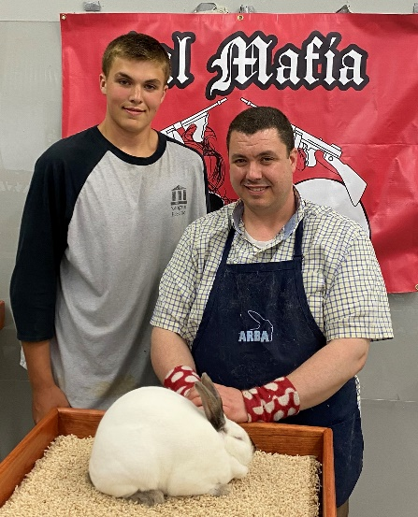
Best Jr Buck Best Jr Doe – Best of Breed
Josiah Claar Josiah Searls

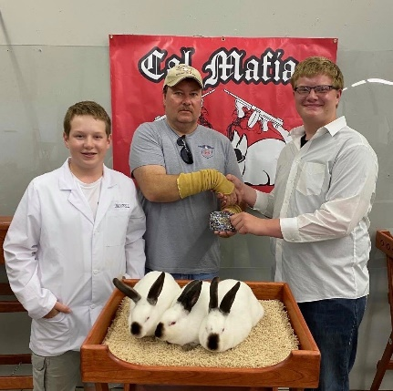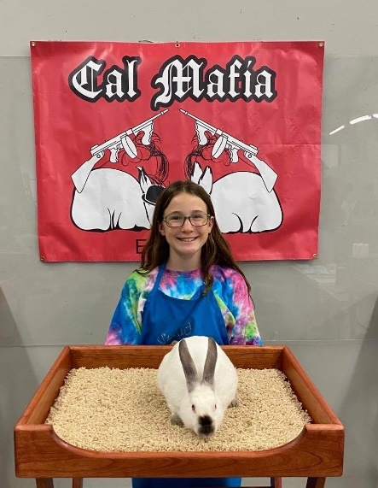
Best Meat Pen Youth Best single fryer Youth
Samuel Pree Haydn Tinsley

