CITY HALL

More Torontonians are willing to hire animal law lawyers to fight ‘dangerous dog’ orders

By Francine Kopun City Hall Bureau
Mon., June 28, 2021
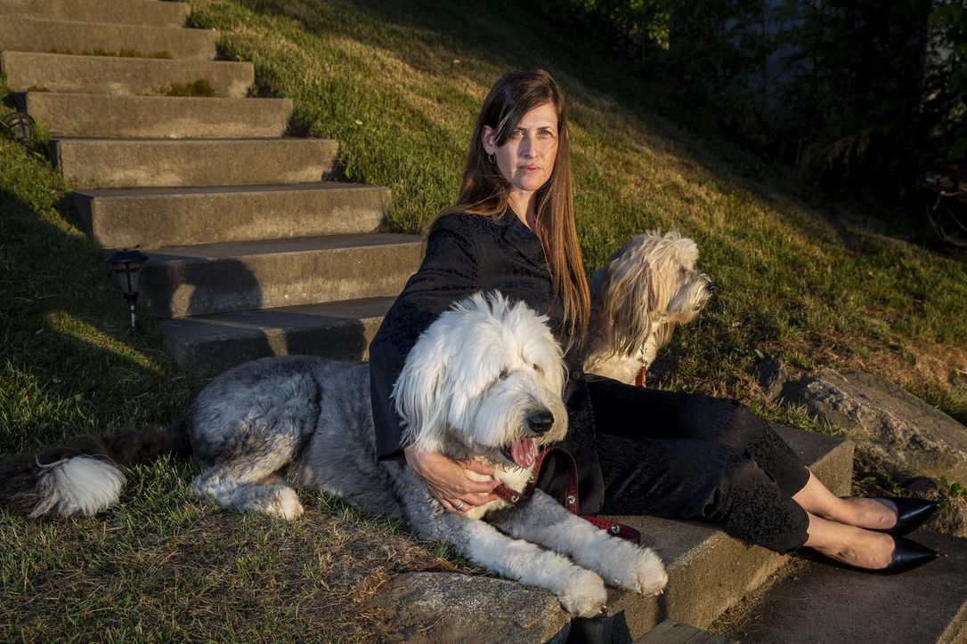

The defendant, Wilbur, did not testify.
The three-year-old Plotthound mix, convicted in March by Toronto Animal Services (TAS) of attacking a woman in her 80s, let his lawyer handle the appeal of his sentence — that he be muzzled and leashed in public at all times, and for the rest of his life.
Wilbur’s lawyer spoke in his defence at a Dangerous Dog Tribunal hearing on Thursday, calling into question the identity of the dog in a video of the March attack, and the means by which TAS arrives at a dangerous dog determination.
The jury is still out on Wilbur, but the verdict is in on the lengths people will go to when it comes to defending their pets.
“They’re family members and when a family member is wrongly accused of engaging in an act, many people, if they have the financial means to do so, will retain counsel to assist them in the process,” says Jennifer Friedman, the lawyer who defended Wilbur on Thursday.
Friedman describes herself as Canada’s animal lawyer, and has worked on behalf of clients at similar tribunals in Brampton and Milton.
“I’m not a dog whisperer, but I do my best to be able to speak on behalf of the clients and do the best for the dogs,” Friedman says.
Friedman is one of a growing number of animal law lawyers in Canada who are being called on to represent animals and their owners in dangerous dog hearings and to protect animals, more generally speaking, from cruelty and neglect, including animals being used for food, fashion, experiments and entertainment.
“It’s absolutely a growing field,” says Camille Labchuk, executive director of Animal Justice, billed as Canada’s only national animal law advocacy organization.
Labchuk remembers that when she decided in 2007 to study law, there was only one animal law lawyer in practice in Toronto. In September, the Canadian Animal Law Conference attracted 400 participants, something that Labchuk says would have been unthinkable a decade ago.
“As long as the person has the means to spend money on their companions, they absolutely will,” said Labchuk.
“In my experience, people consider companion animals to be family members, not just items of furniture or televisions that you can dispose of as you wish. People really think of them as members of their household and members of the family. And so when the companion animal is under threat by a tribunal proceedings, of course, the person with the means to, in my experience, will pretty much always do everything they can to save their family member.”
In Toronto, the Dangerous Dog Tribunal, comprised of three people sitting at any one time, can only confirm or rescind a dangerous dog order. It cannot alter the conditions, which include that the dog be muzzled, leashed and under control at all times while in public.
Owners must also post a warning on their property and obtain training for their dog. Dangerous dogs cannot enter leash-free areas of a city park. The designation is for the life of the dog.
Most appeals to the Toronto tribunal come from the dog owners themselves — sometimes handwritten in pen on paper — but lawyers like Friedman and other legal professionals say they are increasingly being asked to represent people and their pets at such hearings.
Costs can climb quickly — in terms of time and money.
Friedman filed a seven-page defence of Wilbur. She spent an entire day at the tribunal on Thursday and the proceedings are scheduled to resume in July to hear testimony from another witness.
Wilbur’s owners, an RCMP officer and a psychologist, also paid for a three-hour professional assessment of Wilbur in order to prove his lack of aggression.
They enrolled him in a 10-week private obedience training program. They obtained six letters of reference for Wilbur from neighbours and one from Wilbur’s vet, attesting to his good character.
There are financial reasons for hiring a lawyer to represent you at the Dangerous Dog Tribunal, says Leon Presner, a paralegal who was recently hired by a woman defending her German shepherd, who was accused of biting someone.
The victim claimed to have developed cellulitis and nerve damage.
“There’s quite a bit of liability if your dog gets away from you or the dog is unleashed and bites somebody,” Presner said. “It’s financially significant.”
Animal law has come a long way, Friedman points out. There were no animal law courses when she went to law school — she couldn’t even find an instructor to supervise an animal law paper.
She was called to the bar in Ontario in 2003. She was the first general counsel for the Ontario Society for the Prevention of Cruelty to Animals and litigation counsel for the Ontario Racing Commission.
In private practice in 2016, she has the luxury of choosing her clients — she does not represent people accused of animal cruelty.
Friedman and other animal lawyers describe the conditions imposed on dangerous dogs as onerous.
Vancouver animal law lawyer Rebeka Breder says muzzling a dog for life can have a huge impact on their quality of life.

FOLLW YOUR FAVOURITE STAR COLUMNISTS
“A dog who has a scheduled routine, to go on walks to meet up with other dog friends at the dog park, off-leash, to play with a ball or at the beach, can no longer do that. And that could have serious implications on the dog’s welfare,” Breder says.
About 20 per cent of her practice is made up of defending dogs.
“They can become depressed, just like people.”
The TAS sees it differently — relatively few dangerous dog orders are issued, relative to the number of complaints called in. And given the impact of the designation on dogs and their owners, TAS officers issue orders only when it’s deemed necessary to protect the public, the tribunal heard on Thursday.
In 2020, Toronto’s Municipal Licensing and Standards responded to 1,911 service requests related to dangerous acts by a dog. Only 96 dangerous dog orders were issued.
Once the orders have been issued, they are not easy to overturn — the tribunal considered seven appeals in 2020 and rejected all but one.
Friedman and Breder point to animal custody cases as another growth area of animal law, pointing to the COVID-19 pandemic as a possible cause. They speculate that too much time spent alone in close quarters seems to have triggered a wave of separation and divorce.
“I’m seeing a huge rise in those cases,” said Friedman, adding she’s seen couples go so far as to sue one another to ensure access.
“In the same way when human children are involved, it’s often the case where the kids are used as pawns, so the pets are used as pawns as well, so it’s really a sad situation to see, when that materializes.
“It’s unfortunate that that happens but I think that’s a way to demonstrate how people regard their animals and what lengths they’ll go to do protect them.”
By the numbers: Toronto dangerous dog calls
In 2020, Toronto’s Municipal Licensing and Standards responded to 1,911 service requests related to dangerous acts by a dog. Of those calls:
- 307 concerned one animal biting another;
- 802 concerned animals biting people;
- 153 involved animals attacking animals;
- animal-to-human attacks totalled 195 and menacing behaviour, 454.
Source: Dangerous Dog Review Tribunal 2020 Annual Report.

Francine Kopun is a Toronto-based reporter covering city hall and municipal politics for the Star. Follow her on Twitter: @KopunF

