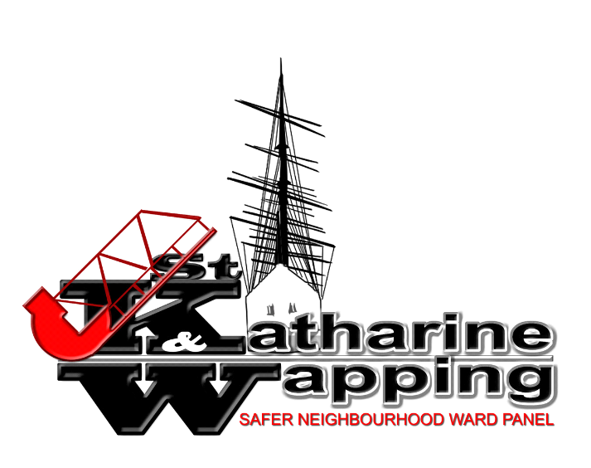

WAPPING BUS GATE SURVEY/CONSULATION – Closing 27th July at 11.59pm

The Wapping Bus Gate has transformed life in Wapping over the last two years. Now Wapping’s calm is in danger, and we need your help to campaign against efforts by the Mayor of Tower Hamlets to shut the Bus Gate down.

BEFORE THE BUS GATE:
- Wapping High Street, Wapping Wall and Glamis Road was a notorious rat-run.
- A constant stream of traffic used Wapping as a shortcut and filled the whole area with noise, congestion and pollution.
- Heavy trucks carrying demolition waste and weighing up to 32 tonnes shook the surrounding buildings.

SINCE THE BUS GATE BEGAN OPERATING:
- Calm has returned to Wapping
- Pollution levels have improved enormously - we can open our windows again
- The roads have become much safer for children walking to school, other pedestrians and cyclists.
- Local residents can now be authorised to drive through the bus gate during its operational hours – ending one of the early objections to it.

Tower Hamlets council is due to deliver a consultation survey to each household in Wapping. This has to be returned by July 27. If you want the Bus Gate to stay it is vital that you respond to the survey. And tell the mayor we think it has brought great benefits to Wapping.

DON’T LET THE MAYOR TURN WAPPING BACK INTO A POLLUTED RAT-RUN

