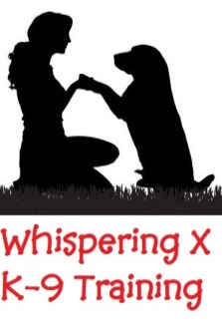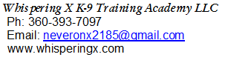
Application, release and indemnification for training classes
Complete his form and submit to Trainer prior to start of class
Name of Handler/Owner:

Address:

Phone: e-mail:

Name of Dog: Age: Breed: Color:

As the Handler/Owner of the above dog I attest that the above named dog has current inoculations against DISTEMPER, INFECTIOUS HEPATITIS, PARAINFLUENZA, PARVOVIRUS, KENNEL COUGH and RABIES and is to the best of my knowledge, a HEALTHY dog. I also agree that I will abide by the rules of the training class and that the dog will not be a hazard to persons or other dogs. I further agree not to hold WhisperingX K-9 Training Academy nor its employees responsible for any loss or injury during the classes at the WXK-9TA or other private facilities. The Instructor reserves the right to dismiss any dog or handler from the class if deemed necessary. Additionally I hereby grant permission to WXK-9TA to use photographs and/or videos of me taken during classes and/or special events in publications, news releases, online, and in other communications related to the mission of WXK-9TA.

Signature (Handler, owner, or parent of Handler if under 18 years of age) Date:
TUITION
- Puppy Stage 1 -- 8 weeks 1 hour/week $125.00, includes AKC-STAR
- Advanced Puppy Stage 2 -- 8 weeks 1 hour/week $125.00, includes AKC-STAR
- Puppy Obedience Stage 3 -- 8 weeks 1 hour/week $135.00, includes AKC-CGC
- Basic Obedience Level 1 -- 8 weeks 1 hour/week $135.00, includes AKC-CGC
- Obedience Community Level 2 -- 8 weeks 1 hour/week $140.00 includes AKC-CGC-A
- Obedience Urban Level 3 -- 8 weeks 1 hour/week $165.00 includes AKC-CGC-U
- Rally/Obedience for competition -- 8 weeks 1½ hour/week $160.00
- Treibball Level 1 or 2 -- 8 weeks 1 hour/week $140.00
- Treibball Level 3 -- 8 weeks 1½ hour/week $170.00
- Trick Dog Class -- 8 weeks 1 hour/week $135.00
- Private Lessons At Training Center $60.00 per hour
- Private Lessons Off-Site within 15 miles $85.00 per hour
- Canine Good Citizen Testing (CGC $25.00, CGC-A $25.00, CGC-U $45.00)
- AKC Trick Dogs (TKN $20.00, TKI $25.00, TKA $30.00, TKP $35.00, TKE 40.00)

Office use only
Class Taken: Payment Type: Amount:

