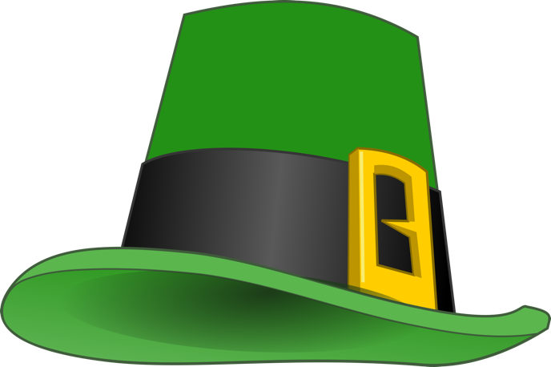

Come and help us celebrate Paddy’s Night

Saturday, 16th March from 7.30pm

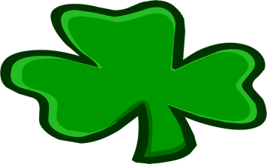
This Photo by Unknown Author is licensed under CC BY-NC
This Photo by Unknown Author is licensed under CC BY-NC

Traditional Irish Dancers from 8pm
“Clayton” (our performer this evening) will then be singing a set of
Irish Music in the Irish Mountain Dew Show
“Clayton” will then follow up with a couple of sets of Live Dance Music

Irish themed drinks at the bar – A Guinness, Baby Guinness, Jameson’s or an Irish Mule!

Tickets £10 Members, £12 Guests
(£2 per ticket reduction for Members only, if bought before February 16th)

Dress Code……wear something Green.

