

**Supplementary ACHD Echo Acquisition Protocol for**

*Repaired Tetralogy of Fallot*

***The following protocol for echo in adult patients with repaired Tetralogy of Fallot (TOF) is a guide for performing a comprehensive assessment of this group of patients. It is intended as a supplementary guide to the ISACHD echo protocol and sequential analysis and all regular measurements should be included. It highlights areas of interest in each view specific to repaired TOF.***

**Background**

TOF is the most common cyanotic congenital heart disease. Anatomic malformations include:

1. RVOT obstruction, typically subpulmonary infundibular stenosis

2. VSD

3. Overriding aorta

4. RV hypertrophy

*Diagram of tetralogy of Fallot. Diagram adapted from Popelova et al*



Infundibular stenosis

Aorta overriding the VSD

**Common associations**

* ASD (~33% of cases) (Tetralogy anatomy + ASD = Pentalogy of Fallot)
* Right aortic arch (25%)
* Coronary artery anomalies (up to 10%). The commonest is when the LAD arises from the RCA & crosses RVOT anteriorly which has important implications for the surgical approach.
* Aortopulmonary or bronchopulmonary collaterals
* 22q11 deletion (15%)
* Persistent left SVC (10%)
* AVSD (2%)

**Surgical approaches**

Strategies and timing of surgical repair have evolved over time. Currently systemic to pulmonary shunts are no longer performed except in rare cases and total repair is done in the first 3-6 months of life.

* RVOT patch + VSD closure – in setting of adequate pulmonary annulus. Procedure of choice
* Transannular RVOT patch + VSD closure – to increase RVOT/pulmonary annulus size
* RV-PA conduit + VSD closure – most often used in the setting of coronary artery anomalies +/- augmentation of pulmonary arteries.
* BT shunt (classic or modified) is a palliative procedure to encourage growth of pulmonary arteries in neonates. Historically, in rare cases, Waterston shunt (ascending aorta to right pulmonary artery) and Potts shunt (descending aorta to left pulmonary artery) were performed.

**Residual anatomic and haemodynamic lesions in repaired TOF**

* Residual pulmonary regurgitation
* Residual or recurrent RVOT obstruction and branch PA stenosis
* Akinetic RVOT free wall and RV dilatation and dysfunction
* Restrictive RV
* Residual VSD, ASD
* Tricuspid regurgitation
* Aortic dilatation and regurgitation
* Left ventricular dysfunction
* Conduction and rhythm abnormalities

**Imaging protocol for repaired Tetralogy of Fallot**

|  |  |
| --- | --- |
| Subcostal views | * Establish abdominal and atrial situs, cardiac position & direction of apex * Assess IVC size & collapse to assess RA pressure * Hepatic venous Doppler to assess for increased A wave reversal velocity * Ventricular septum for residual VSDs * Anterior angulation to assess anatomy and function of right ventricular outflow * RV wall thickness and RV function |
| Parasternal views | * Overall RV function including specifically the anterior wall & outflow tract * RVOT anatomy – aneurysmal, narrowing * Pulmonary valve annulus diameter, function, degree of PR * Doppler of pulmonary valve for gradients & estimation of pulmonary pressures, including presence of forward ‘a’ wave indicating restrictive RV physiology * Identify level of stenosis where relevant * Anatomy of main pulmonary artery and proximal branches, including branch dimensions. * Ventricular septal motion for signs of volume or pressure overload * Aortic annulus, root and ascending aorta diameters, degree of AR * Integrity of VSD patch * Dilatation of coronary sinus |
| Apical views | * Detailed LV function assessment. * Assess aortic valve function * Detailed RV size and function assessment including fractional area change. * Anterior angulation to assess anatomy and function of right ventricular outflow * Assess tricuspid valve function * Posterior angulation to coronary sinus |
| Suprasternal views | * Assessment of arch sided-ness by demonstrating innominate artery bifurcation. * Assessment of branch pulmonary arteries and PR * Assessment of right +/- left-sided SVC in the setting of dilated coronary sinus * Wide sweeps to assess for aortopulmonary or bronchopulmonary collaterals |

**Repaired Tetralogy of Fallot Reports**

Key points to include in transthoracic echo report:

* RV size, systolic and diastolic function
* Pulmonary valve function
* VSD patch integrity
* Aortic root dilatation
* Estimate of pulmonary pressure
* Assess for PA branch stenosis

**Key views specific to ToF repair patients:**

**Parasternal long axis view**

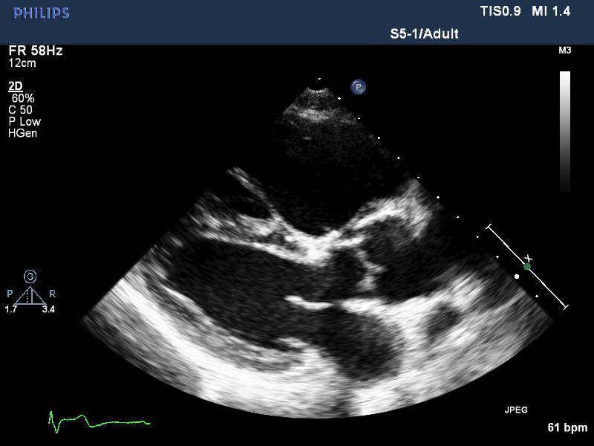

Figure 1 The arrow points to the VSD patch which is brighter than the myocardium. Note that the aortic root still slightly overrides the ventricular septum. The right ventricle is dilated as is commonly seen in adults with repaired ToF, usually associated with pulmonary regurgitation.

**Parasternal short axis views**

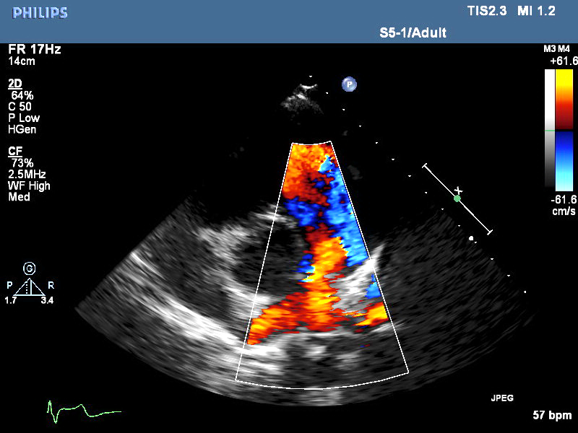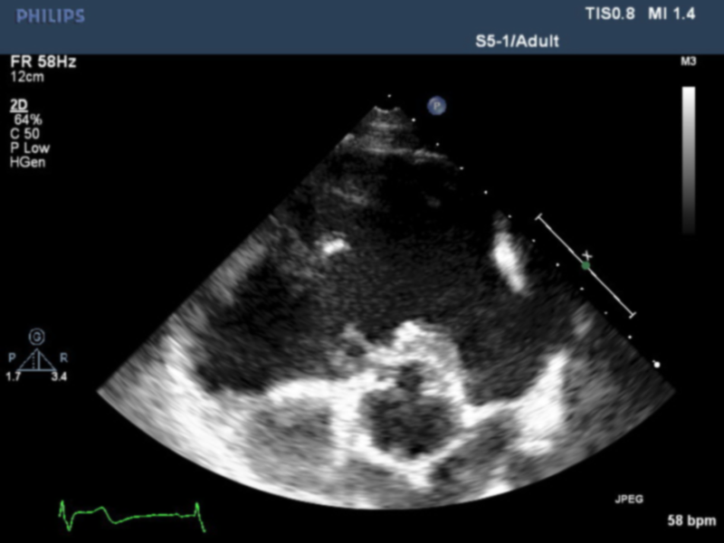

Figure 3 PA bifurcation: Diastolic flow reversal is noted in the pulmonary branches indicating severe PR, a common finding in repaired ToF. The trans-annular patch interrupts the integrity of the pulmonary annulus.

Figure 2 The RVOT is dilated and usually has some akinetic regions following repair using the trans-annular patch technique. The aortic root appears irregular due to the VSD patch. Careful interrogation with CFI is warranted to exclude residual VSDs.

Figure 4 CW Doppler profile of the pulmonary valve: Note the PR ends prematurely in mid diastole due to rapid equalisation of RV & PA pressures. This can indicate severe PR (combined with a wide colour jet).

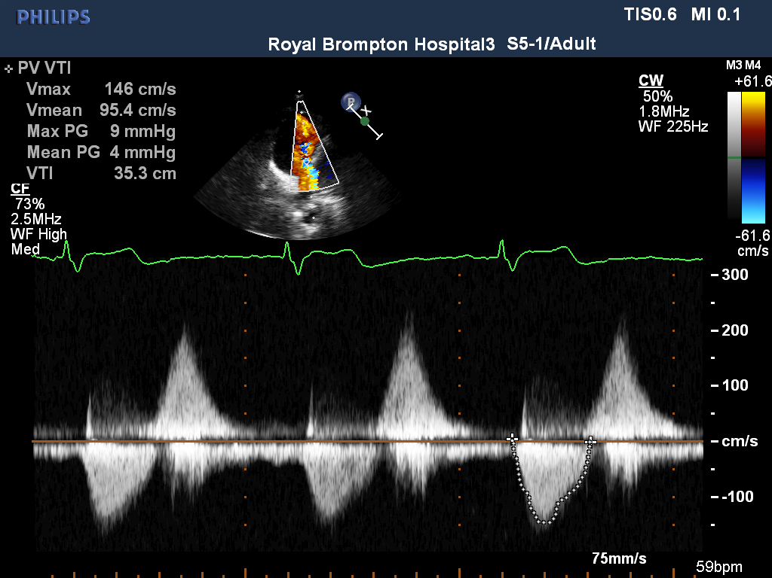

**PW RVOT Doppler**

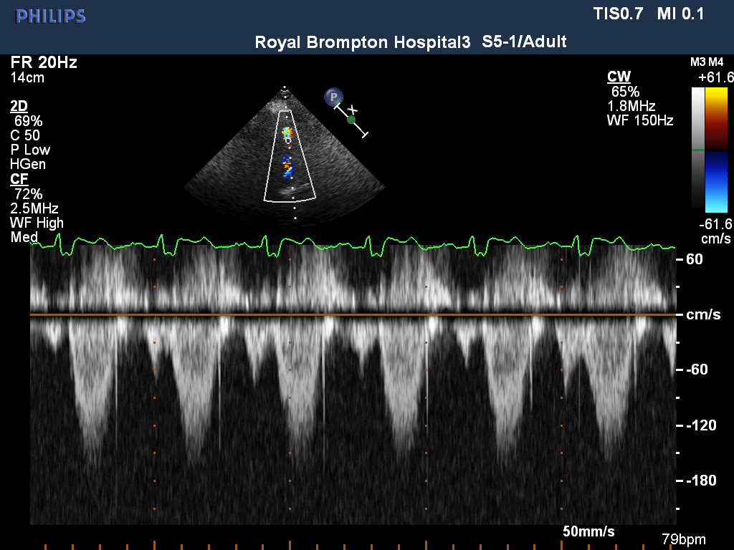

Figure 5. PW Doppler, with Doppler sample at the tip of the pulmonary valve, demonstrates forward flow following atrial systole or a forward ‘a wave’. This suggests RVEDP is markedly elevated, higher than PAEDP which opens the pulmonary valve during atrial systole. It can vary throughout the respiratory cycle. RV restrictive physiology is suggested when the forward a wave is present for 5 consecutive beats during normal respiration. This is often complemented by high velocity atrial reversals in the hepatic veins.