Echocardiographic Assessment of Fontan/TCPC repairs

The following protocol for echo in adult patients following Fontan or TCPC procedure is intended as a guide for performing a comprehensive assessment of this group of patients. It is intended as a supplementary guide to the ISACHD echo protocol and sequential analysis and all regular measurements should be included where valid. It highlights areas of interest in each view specific to Fontan or TCPC evaluation.

Background:

The terms ‘Fontan Operation’ & ‘Total Cavopulmonary Connection’ (‘TCPC’) indicate a concept of circulatory flow rather than a specific type of operation. There are several surgical techniques used to achieve the same outcome.

The main aim of the Fontan circulation is to separate pulmonary & systemic circulations by removing the systemic venous return & its deoxygenated blood from the heart. A single ventricle (or functional single ventricle) often pumps both the systemic and pulmonary circulations. In many cases, the native anatomy also involved a single ventricle physiology.

In Fontan physiology:
- IVC flow is channelled directly to the pulmonary artery and so the circulation bypasses the sub-pulmonary ventricular pump which is small and rudimentary in many cases.
- Multiple step operations are required usually consisting of a Glenn followed by completion of the TCPC.

Bidirectional Glenn operation:
- the SVC is disconnected from the right atrium and redirected into the right pulmonary artery, which remains confluent, hence flow is bidirectional – to both left and right pulmonary arteries.

- Where a left SVC persists, a left-sided SVC-LPA anastomosis can be performed, so creating a bilateral bidirectional Glenn.

- A Glenn operation is not always associated with a complete TCPC. It is sometimes used in isolation e.g.. repair of Ebstein’s anomaly to improve flow to the pulmonary arteries and to unload a small right ventricle. This is also known as a one-and-a-half ventricular repair.

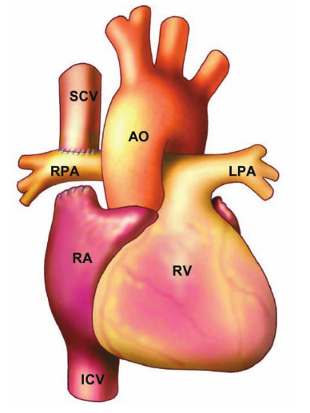
Diagram 1. Bidirectional Glenn operation with confluence of the pulmonary arteries. Diagram from Popelová et al. Congenital Heart Disease in Adults, 2008.

Fontan or TCPC – Are they the same?

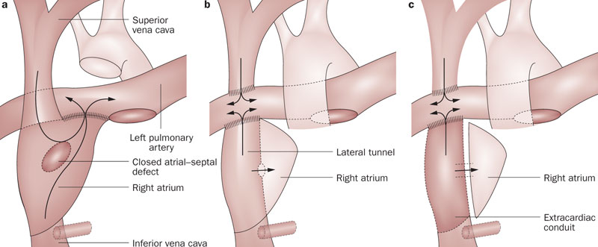
Diagram 2 a) An atriopulmonary Fontan, b) Lateral tunnel TCPC, c) extracardiac TCPC. Diagram from Marc R. de Leval & John E. Deanfield Nature Reviews Cardiology 7, 520-527 (September 2010)

1. Atriopulmonary (AP) Fontan

An AP Fontan operation usually describes a direct AP connection by opening the right atrial appendage directly into the main pulmonary artery with no artificial tubes/patches. If a tricuspid valve or atrial septal defect was present, they were both patched closed, and the main pulmonary artery was disconnected often about 1cm above the pulmonary valve. It is sometimes performed with a Glenn operation or, the SVC is left to drain normally into the right atrium. The AP Fontan operation is no longer performed in infants due to its undesirable long term effects of right atrial distension leading to arrhythmias, thrombus & pulmonary venous obstruction.

Post operative sequelae specific to AP Fontan:
- Right atrial dilatation leading to arrhythmias and/or thrombus formation
- Pulmonary venous obstruction
- Narrowing of anastomosis site.

2. Lateral tunnel TCPC

A lateral tunnel TCPC refers to a tunnel (Gore-Tex/Dacron) inserted into the right atrium which directs blood from the inferior vena cava through the right atrium and into the right pulmonary artery. It allows the right atrioventricular valve to contribute to the systemic circulation. In the apical 4 chamber view, a circular structure is noted in the right atrium. A bidirectional Glenn is performed to carry SVC flow directly to the right pulmonary artery. Fenestration in the systemic atrium is performed at the time of operation if the pulmonary vascular resistance is borderline high. The fenestration allows for offloading of increased pressure within the conduit and is vital to keep the Fontan circulation functional. The gradient of the fenestration represents the difference between pulmonary artery & right atrial pressure (i.e. the transpulmonary gradient, which is determined by the PVR) and should usually be 5-8mmHg. Fenestrations are sometimes closed with septal occluder devices later in life if they cause ongoing cyanosis.

Post operative sequelae specific to lateral tunnel TCPC:
- Narrowing of conduit
- Thrombus in conduit
- Spontaneous closure of fenestration if present

3. Extracardiac TCPC

An extracardiac TCPC is a conduit which, like a lateral tunnel, directs blood from the inferior vena cava into the right pulmonary artery, however it is not within the atrial cavity, and so allows both the right atrium and right atrioventricular valve to contribute towards the systemic circulation. It is the current approach and it is hoped that it will reduce the incidence of atrial arrhythmias. A bidirectional Glenn is also performed. The extracardiac approach allows for better streamlining of blood flow from the IVC directly superiorly to the right pulmonary artery.

Indication of Fontan/TCPC:
- Any pathology where either ventricular chamber is hypoplastic & unlikely to successfully support either a pulmonary or systemic circulation on its own. This includes, but is not restricted to, tricuspid or mitral atresia.
- Any pathology where atrioventricular valve chordae straddle the septum, preventing VSD closure and therefore also preventing biventricular repair. This includes, but is not restricted to, double inlet ventricles, AVSDs.

Post-operative Sequelae common to all surgical techniques
- Ventricular dysfunction, systolic and diastolic.
- Complications with conduits – narrowing, obstruction, leaks, thrombus formation
- Atrioventricular valve and /or aortic valve regurgitation which increases systemic ventricular volume loading and pulmonary (Fontan) pressures.
- Restrictive VSD in patient with tricuspid atresia or double inlet LV with VA discordance. Haemodynamic effect of restrictive VSD is similar to that of sub-aortic stenosis.

Imaging protocol for Fontan/TCPC repair
Imaging Window | Assessment particular to Fontan/TCPC
Subcostal view | - Assess situs, cardiac position and direction of apex  - Assess hepatic veins for dilatation and IVC collapse (2D & Doppler)  - Assess TCPC patency by following IVC flow  - Assess SVC drainage (in AP Fontan)  - Exclude RA or conduit thrombus
Apical views | - Establish AV and VA connection  - Ventricular function assessment  - Assess AV & aortic valve function  - Exclude restrictive ASD or VSD where applicable  - Diastolic function assessment –ventricular inflow and pulmonary venous inflow, for serial comparison  - Exclude pulmonary venous compression  - Assess TCPC patency, fenestration size & mean gradient  - Exclude intracardiac or intraconduit thrombus
Parasternal views | - Assess ventricular size where possible for serial comparison  - Assess ventricular morphology  - Establish VA connection  - Exclude restrictive VSD  - Exclude thrombus  - Valvular assessment  - Assess pulmonary arteries in SAX views  - Assess atriopulmonary connection and TCPC patency when possible, including PW Doppler to identify respiratory variation of blood flow.
Suprasternal views (including supraclavicular views). | - Assess Glenn patency  - Assess TCPC patency at pulmonary artery end where possible, using PW Doppler to identify respiratory variation.  - Exclude pulmonary branch stenosis and coarctation  - Assess for aorto-pulmonary collateral flow

Single ventricle reports:
Key points to include in transthoracic echo report:
- A clear description of anatomy is required using the sequential segmental analysis
- Ventricular function
- Valvular function
- Any obstruction – across septal defects, valves, vessels or conduits
- Patency of connections
- Thrombus
- Fenestration gradient if present

Assessment of single ventricular function:
- Conventional parameters for assessment of either left or right ventricular function are not applicable due to the unique geometry of the single ventricle +/- contribution of the
rudimentary chamber.
- In situations where the single ventricle is a morphological left ventricle and maintains its basic shape, e.g. tricuspid atresia, Simpson’s biplane EF can still be useful.
- Outside of visual estimation, fractional area change may be the most reliable method for serial assessment as it makes no geometric assumptions.
- Other methods which do not rely on geometry may be useful:
  - Myocardial performance index
  - Isovolumic acceleration time
  - Systolic to diastolic (S:D) ratio from AV valve Doppler

Assessment of Connections:

The normal Doppler profile of flow in a Glenn or TCPC depends on the type of surgery performed. The general principles for both connections are the same. Optimisation of colour flow scales (low Nyquist limit) & spectral Doppler (scale & low velocity filter settings) is strongly recommended.

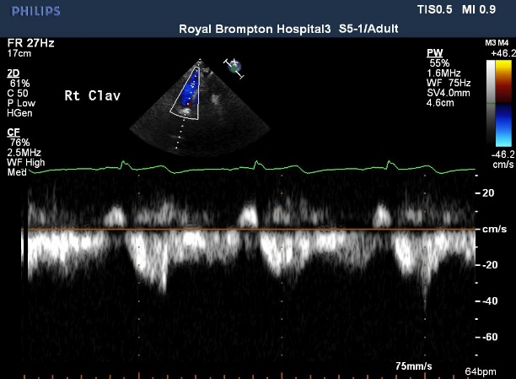

Figure 1 Normal Glenn flow in AP Fontan:
Note that after the p wave, flow reversal is noted in the Glenn connection, due to a transient rise in right atrial pressure resulting from contraction of the right atrium. Flow is low velocity and phasic, returning to the baseline with every cardiac cycle.

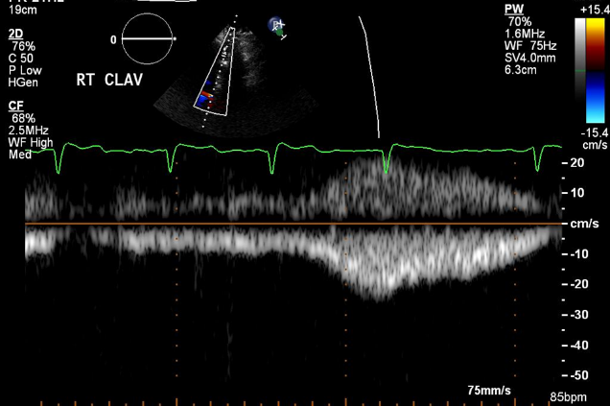
Figure 2 Effect of the respiratory cycle:
It should be noted that Fontan circulations are driven by both the cardiac cycle and the respiratory cycle. Respiratory variation in flow in the connections is considered as a helpful adjunct to help the circulation. During inspiration, the negative pressure is created in the intrathoracic cavity, which helps to ‘suck’ blood into the pulmonary circulation.

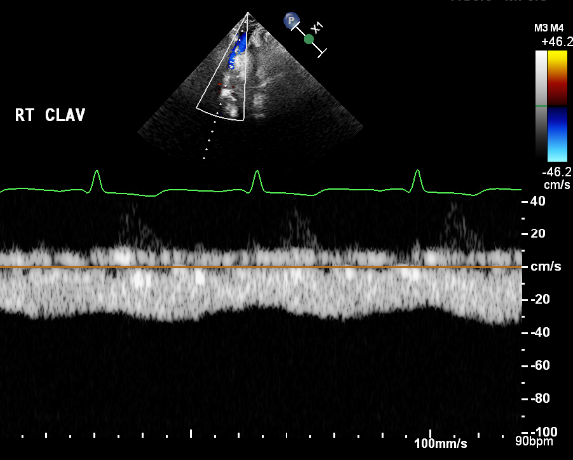

Figure 3 Conduit stenosis:
In this example, there is a continuous gradient between
the non-pulsatile superior vena cava and the right atrium. This
suggests a degree of partial obstruction. Complete obstruction
will result in no forward flow.

5 important considerations for comprehensive echocardiographic assessment
of patients following Fontan/TCPC operations

- Know & understand the original anatomy
  - The group of patients selected for TCPC is heterogeneous. Knowing if holes should be open or closed, if they are unimportant or vital, can make life-saving differences to theinterpretation of the examination.

- Read the surgical notes
  - There are 3 main operations which are seen in adult patients, but beware that variations are common.
  - It is important to know which connections have been made (e.g. Björk procedure or RA to RV Fontan).
  - And beware of the 3rd connection (most likely in the setting of a persistent left SVC).

- Understanding normal relationships helps to find connections
  - To find the conduits requires an excellent command of 3-dimensional spatial orientation and echo acoustic windows. Think in terms of anterior or posterior rather than sticking to conventional echo views.

- Know how to drive the echo machine
  - Especially colour Doppler scale, gains & spectral Doppler low velocity filters
  - Fontan flow is low and slow. Default machine settings will nearly always fail to see the venous flow.

- Serial evaluation is the best assessment
- Due to the heterogeneity of the group, the patient is their own best control. Sometimes the changes can be subtle but important. Compare ventricular function, diastolic parameters and valvular regurgitation using side-by-side images from the current and previous exams.

Key views specific to Fontan/TCPC repairs:
To view the proximal end of the IVC connection:
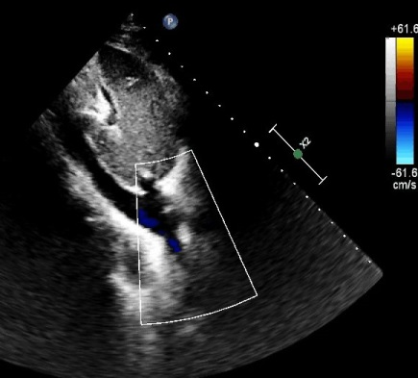
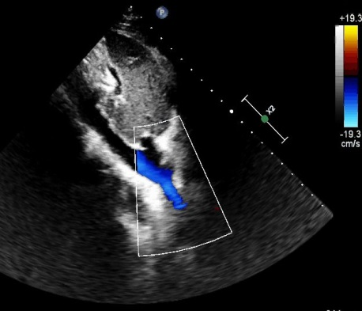

Figure 4 Subcostal short axis view of the IVC end of the conduit. Follow the flow from the IVC as it courses superiorly away from the abdomen (blue flow). Note the significant reduction of colour scale makes the flow easier to follow.

Imaging RA connections in AP Fontan:
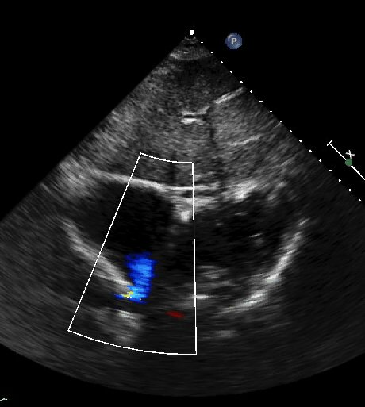
Figure 5 Subcostal 4 chamber view with superior angulation. The connection is seen with blue flow travelling away from the right atrium – the AP connection is frequently in close proximity to the usual SVC-RA junction (red flow, not seen in this image).

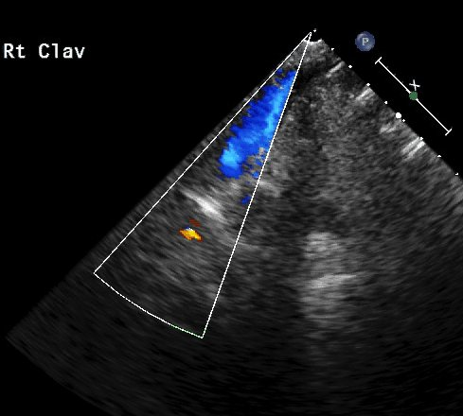
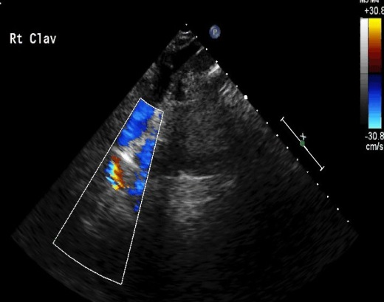
Imaging the Glenn Connection:
Figure 6 Images of the SVC from the right supraclavicular view. Left) SVC flow is noted travelling inferiorly towards the junction of the Glenn connection with the right pulmonary artery. Right) red colour flow from the distal end of the TCPC is noted flowing superiorly towards the right pulmonary artery [this view not always obtainable]. Note the significant reduction of colour scale makes the flow easier to follow.

