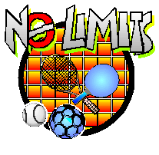

No Limits Newsletter October 2021

Contents page

Cover page……………………………………………………………………………………Page 1

Contents page……………………………………………………………………………….Page 1

Saturday No Limits sports Club sessions are back ………………………………….Page 2

Update on what we do at the Saturday No Limits sports club sessions…………Page 3

What we did at the at the No Limits Skype/Zoom club……………………………….Page 4

No Limits jokes ……..…………………………………………………………………….Page 5

No Limits Quiz………………………………………………………………………………..Page 5

No Limits Quiz Answers…………………………………………………………………..Page 6

Drawing Page……………………………………………………………………………….Page 7

Page 2

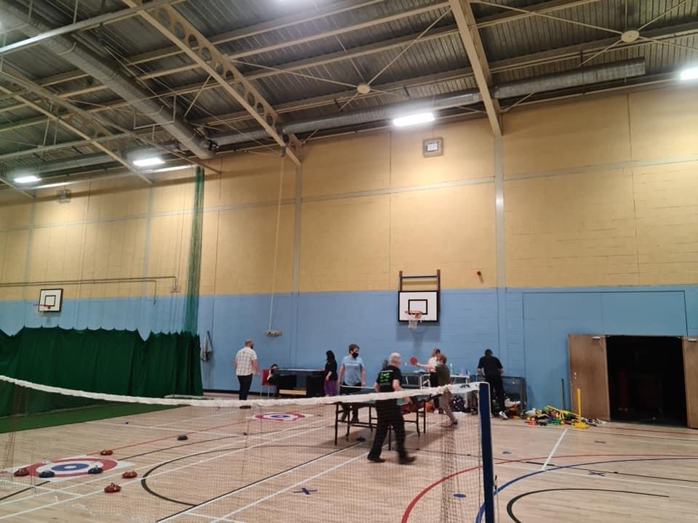
Saturday No Limits sports club sessions are back
We are very pleased to announce that the No Limits sports club sessions on a Saturday are back up and running again.
The Saturday No Limits sports club sessions resumed on Saturday 5th June 2021.

When the sessions resumed there were two sessions available, the first session was at 11am until noon, where we met up outside Linlithgow Sports Centre, split into two groups and we went for a walk from the Linlithgow Sports Centre, along by the Linlithgow canal, one group heading east the other west and then after 30minutes we walked back to the sports centre.
The second session was 12PM until 1pm. In the second session which was limited to 15 people went into the Linlithgow sports centre and into the main sports hall.
During the second session we had the usual mix of activities such as Boccia, carpet bowls, table tennis, the air hockey table and badminton. There were fewer sports on offer because of the COVID restrictions. Everyone who came to the No Limits sports club sessions were and still are encouraged to wear face masks.
There were cleaning stations spaced around the sports hall, at each cleaning station there was a hand sanitizer and cleaning spray to clean any equipment that has been used and paper towels were also available. Social distancing (this means people staying two meters away from each other) was encouraged wherever possible, however we are aware that carers may need to stay close to those they are caring for.

When people arrived they had to put their name down on the No Limits sports club register as usual, but they also had to get their temperature taken by a committee member and were asked to leave details for the track and trace system.

Page 3

Update on what we do at the Saturday No Limits sports club sessions

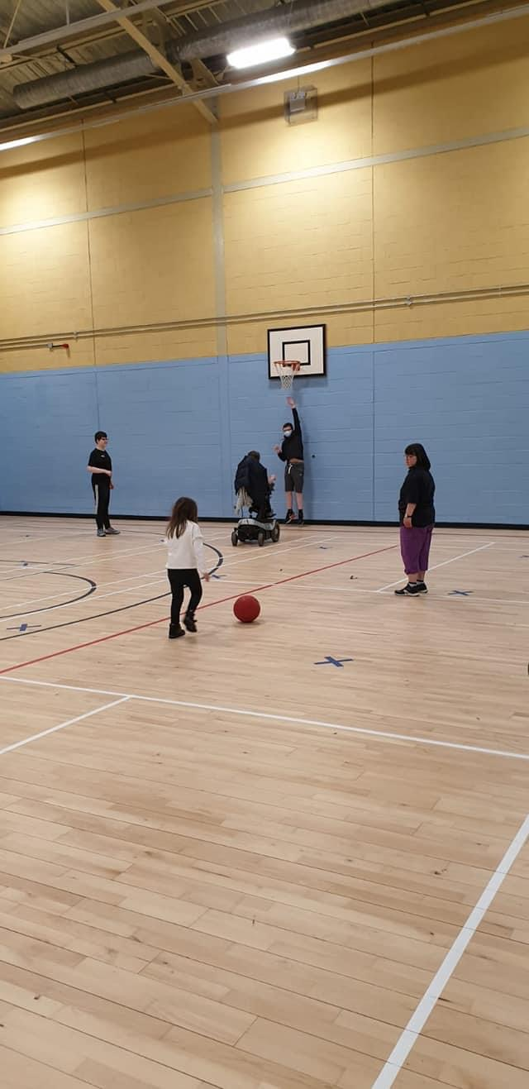
The Saturday No Limits sports club sessions are no longer split into two separate sessions.
The No Limits sports club Saturday sessions are now running from 11am until 1pm (in one long session but split into two halves).
During the first session in the near end of the sports hall we have badminton, table tennis and carpet bowls, new age curling, darts and the small basketball hoop we also have the air hockey table.
At the far end of the sports hall, we usually have Boccia during the first half and then an organised game in the second half.
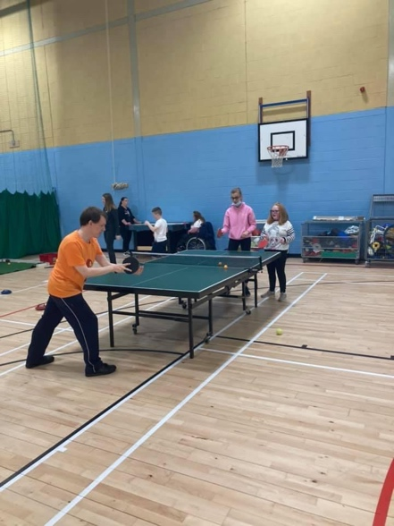
During the second half of the Saturday No Limits sports club sessions, at the near end of the sports hall we continue to do the same activities as we did in the first half of the No Limits sports club sessions. At the far end of the sports hall during the second half of the Saturday No Limits sports club sessions we do a group activity like hockey, football or basketball.

Page 4

What we did at the No Limits Skype/ Zoom club

From March 2020 to April 2020 we had No Limits Skype sessions because of the COVID situation.
In April 2020 we had to move the sessions to zoom because of technical problems.
From April 2020 to the start of June 2021 we had Zoom sessions. When the No Limits Skype/Zoom sessions first started up we met via Skype from 11am until 12PM every Saturday morning, the sessions would start off with a warm up and everyone telling each other what we had done that week and we would finish off by everyone telling each other some jokes.
After a few weeks we decided to do film reviews every week, each week Fiona Hagenbuch would choose 3 Netflix films and she would do a summary of each film that would be read out at the No Limits Skype/zoom sessions on a Saturday, then we would all vote for our favourite film out of the choices.
After a few months Arthur Lawson and Fiona Hagenbuch took it in turns to choose films from Netflix or from the Disney app that people could vote on to choose from to vote for the film we would watch that week. Sometimes we would watch a Disney film and sometimes we watch a Netflix film to discuss and review on the following Saturday.
Paul created the No Limits ‘Hello’ song which we would all sing together at the start of each session.
Paul also created the No Limits ‘Goodbye’ song, which we would all sing at the end of the session.
Fiona Hagenbuch translated the songs into ‘Sign Along’.
After that some of us took part in the songs using it alone –others tried a combination.
We also had music sessions starring Jack Matheson most weeks but also starring Arthur Lawson as well.
After a few months Fiona created a weekly quiz which became very popular but also
very competitive. Although the sessions have now finished, everyone who joined them seemed to enjoy them.
Each member who took part in the sessions contributed in their own unique and individual way, some people used ‘Sign Along’ to communicate and I think we all learned a bit of signing along the way.
I think we all helped each other get through a difficult year and I would like to thank everybody who took part in the No Limits Skype/zoom sessions.
I would like to say a special thank you to for running the Skype/zoom sessions and I would also like to thank the No Limits Committee for their part in making the Skype/zoom sessions happen. In particular Mark McEwan for setting up the Skype sessions originally. I would also like to thank Alan Churne for helping to set up the No Limits zoom sessions.

Page 5

No Limits jokes

1.What kind of cats like to go bowling?
Answer: Alley cats
2. What do you call a sleeping bull?
Answer: A bull dozer
3. What is an astronaut’s favourite snack
Answer: Space chips
4 Why did the cycle fall over?
Answer: Because it was two tired
5. What do you call a pig that does karate?
Answer: A pork chop
6..Can a kangaroo jump higher than the Empire State Building?
Answer: No, the Empire State Building can’t jump
7.Why do bees have sticky hair?
Answer: Because they use honey combs
8.. Why did the barber win the race?
Answer: Because he knew a short cut
9. What bean do kids love?
Answer: A jelly bean
10.What bone will a dog never eat?
Answer: A trombone

No Limits Quiz

- What are the vowels of the English alphabet?

2.Which Disney film includes the hit song 'Let It Go'?

3. How many years are there in one Millennium?

4. Who is the bear in 'The Jungle Book'?

5. How many legs does a spider have?

6. Where does Mike Wazowski go with his girlfriend Celia for her birthday feast in ‘Monsters Inc.’?

7. How many hours do we have in a day?

8. The Genie was clasped in the lamp for how many years before Aladdin discovered him?

9. What are the colours of a rainbow?

10. Which poisonous fruit did Snow White eat?

Page 6

Quiz answers

- Answer: A, E, I, O, U

- Answer: 'Frozen'
.
- Answer: 1,000 years
4.Answer: Balloo.
5. Answer: A spider has 8 legs
6. Answer: Harryhausen’s.
7. .Answer: 24 hours
8. Answer: 10,000 years
9. Answer: Red, Orange, Green, Blue, Yellow, Indigo, and Violet.
10. Answer: Apple

Page 7

Fun Time: Colouring Page

Draw us a picture and e- mail it to - info@nolimitssportsclub.org

This Newsletter was compiled by Fiona Hagenbuch

